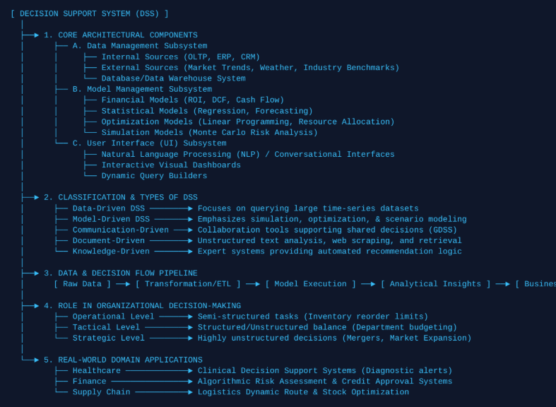
Concept Map 1: Decision Support Systems (DSS)
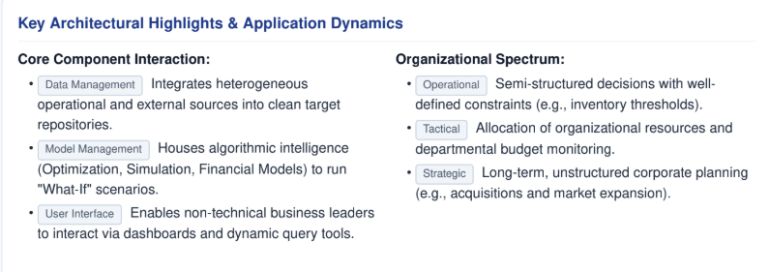

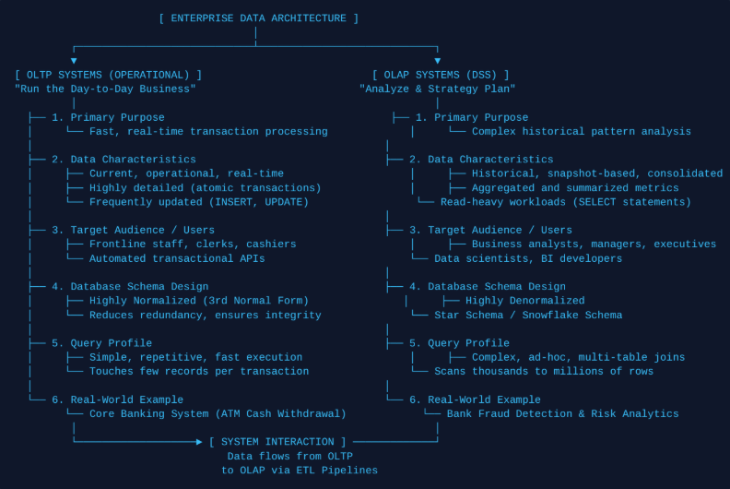
Concept Map 2: Operational Systems (OLTP) vs. Decision Support Systems (OLAP)

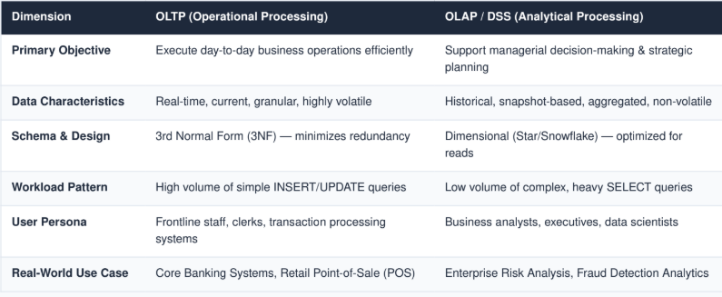

Concept Map 3: Architecture of a Data Warehouse

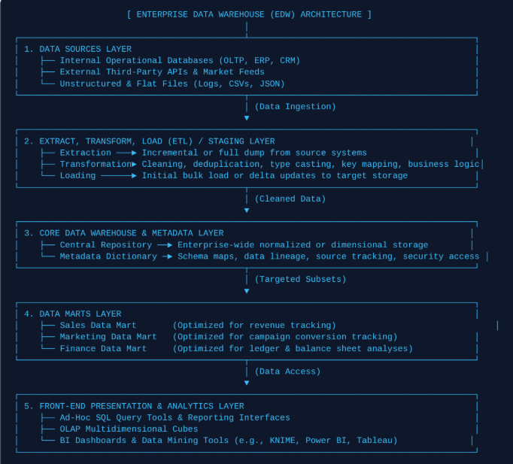

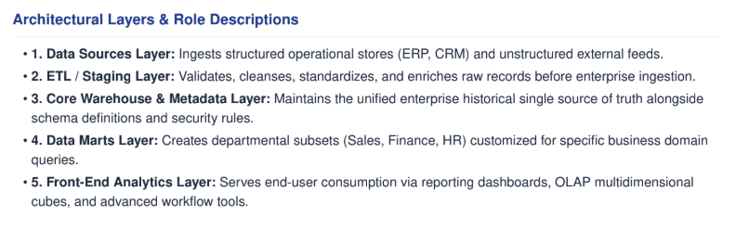

Concept Map 4: OLAP, Data Cubes & Dimensional Modelling
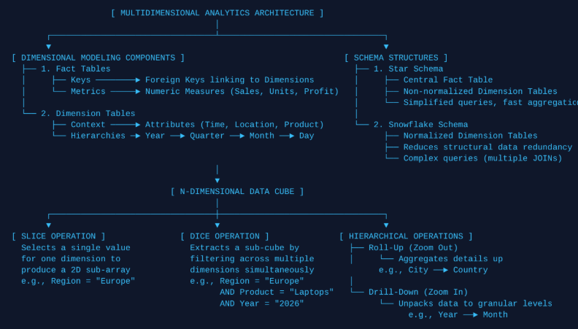

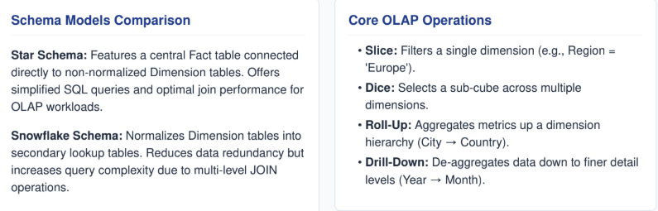

│

Concept Map 5: Query Processing & BI Tools (KNIME Integration)

